P3 Topic 5
Kinetic theory and gases

Questions
Q1.
(a) Which graph shows the way in which the average kinetic energy of the molecules of a gas changes with temperature?
Put a cross ( ) in the box next to your answer.
(1)
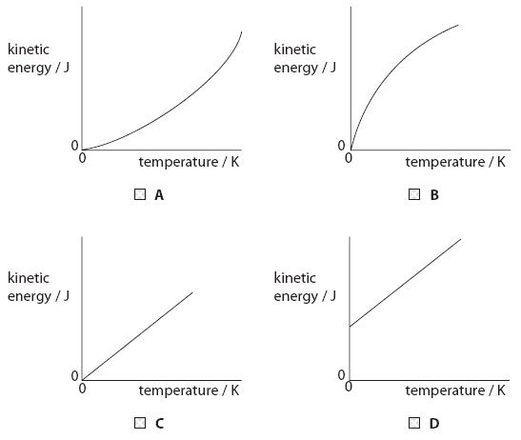
(b) The photograph shows a scuba diver.
She can breathe under water because she carries a cylinder of air on her back.
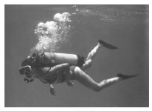
(i) The air molecules in the cylinder move randomly.
Describe how these air molecules exert a pressure on the cylinder.
(2)
..............................................................................................................................................
..............................................................................................................................................
..............................................................................................................................................
..............................................................................................................................................
(ii) The cylinder contains air at a pressure of 21 000 kPa.
The volume of air in the cylinder is 15.0 litres.
When the valve on the cylinder is opened, the air expands until its pressure is 100 kPa.
The temperature of the air does not change.
Show that the new volume of air is about 3 200 litres.
(2)

(iii) The cylinder is filled with air in a hot country and then taken to a cold country.
The temperature in the hot country is 305 K.
The temperature in the cold country is 278 K.
The pressure in the cylinder in the hot country is 21 000 kPa.
Calculate the pressure in the cylinder in the cold country.
(3)

..............................................................................................................................................
(Total for Question = 8 marks)

Q2.
Which graph shows the way in which the average kinetic energy of the molecules of a gas changes with temperature?
Put a cross ( ) in the box next to your answer.
(1)

Q3.
The photograph shows a scuba diver.
She can breathe under water because she carries a cylinder of air on her back.
(i) The air molecules in the cylinder move randomly.
Describe how these air molecules exert a pressure on the cylinder.
(2)
..............................................................................................................................................
..............................................................................................................................................
..............................................................................................................................................
..............................................................................................................................................
(ii) The cylinder contains air at a pressure of 21 000 kPa.
The volume of air in the cylinder is 15.0 litres.
When the valve on the cylinder is opened, the air expands until its pressure is 100 kPa.
The temperature of the air does not change.
Show that the new volume of air is about 3 200 litres.
(2)

(iii) The cylinder is filled with air in a hot country and then taken to a cold country.
The temperature in the hot country is 305 K.
The temperature in the cold country is 278 K.
The pressure in the cylinder in the hot country is 21 000 kPa.
Calculate the pressure in the cylinder in the cold country.
(3)

..............................................................................................................................................

Mark Scheme
Q1.
 | Answer | Acceptable answers | Mark
(a) | C (graph C) |  | (1)
(b)(i) | A description including:  • collisions (1)  • with (walls of) cylinder (1) | hit / bounce off exert force | (2)
(b)(ii) | substitution (1)  either  100 × V = 15.0 × 21 000  or  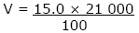evaluation (1)  3 150(litres) | V₁P₁ = 15 × 21000 = 315000 (1 mark) V₂P₂ = 100 × 3200 = 320000 (1 mark) award full marks for  3150 (litres) without working | (2)
(b)(iii) | substitution (1)  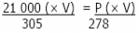volume same (1) evaluation (1)  19 100 (kPa) | give full marks for correct answer, no working transposition accept 19141 (kPa) or 19000  and numbers rounding  down to 191 00 | (3)

Q2.
 | Answer | Acceptable answers | Mark
 | C (graph C) |  | (1)

Q3.
 | Answer | Acceptable answers | Mark
(i) | A description including:  • collisions (1)  • with (walls of) cylinder (1) | hit / bounce off exert force | (2)
(ii) | substitution (1)  either  100 × V = 15.0 × 21 000  or  evaluation (1)  3 150(litres) | V₁P₁ = 15 × 21000 = 315000 (1 mark) V₂P₂ = 100 × 3200 = 320000 (1 mark) award full marks for  3150 (litres) without working | (2)
(iii) | substitution (1)  volume same (1) evaluation (1)  19 100 (kPa) | give full marks for correct answer, no working transposition accept 19141 (kPa) or 19000  and numbers rounding  down to 191 00 | (3)

Examiner's Report
Q1.
(b)(i)
The marks here were for collisions between the air molecules and the walls of the container.
As expected, the vast majority of candidates scored both marks here.
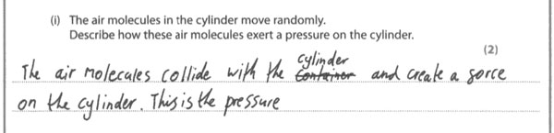
Results Plus: Examiner Comments
This does not talk about the walls of the cylinder but the meaning is clear, especially with the mention of the force.

(b)(ii)
This was a calculation about a gas expanding at constant temperature. The majority of candidates scored both marks.
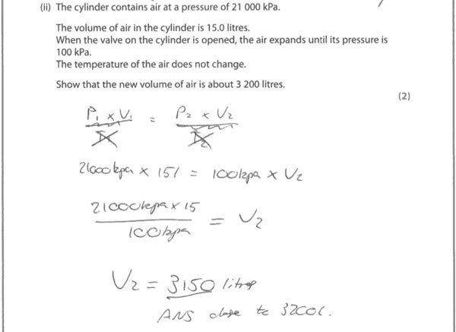
Results Plus: Examiner Comments
A well set out response, finishing with the statement that 3150 is close to 3200.

Results Plus: Examiner Tip
Treat 'Show that...' questions like ordinary calculations. They are usually used to make sure that a correct value is used in the next part of the question.

(b)(iii)
This was a more challenging calculation, involving realising the volume was constant and then rearranging the equation. Even so, more than half the candidates were able to score all 3 marks.
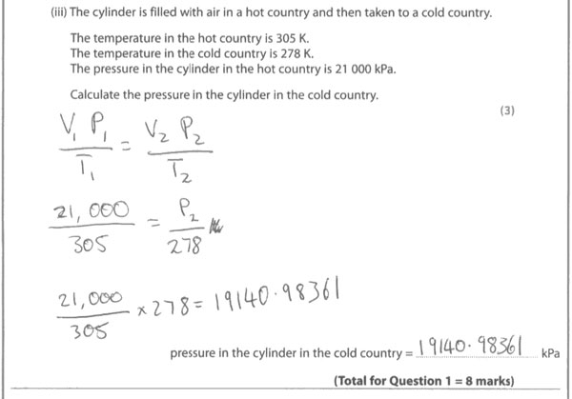
Results Plus: Examiner Comments
Good, clear substitution in and rearrangement of the equation, clearly recognising that the volume does not change. Very easy to follow and reduces the chances of making a mistake in the calculation. 3 marks awarded.

Results Plus: Examiner Tip
There are too many figures quoted in the answer here. It is good to remember that the number of significant figures in the answer should be the same as in the question. In this case, that is 3 significant figures.

Q2.
No Examiner's Report available for this question

Q3.
(i)
The marks here were for collisions between the air molecules and the walls of the container.
As expected, the vast majority of candidates scored both marks here.
Results Plus: Examiner Comments
This does not talk about the walls of the cylinder but the meaning is clear, especially with the mention of the force.

(ii)
This was a calculation about a gas expanding at constant temperature. The majority of candidates scored both marks.
Results Plus: Examiner Comments
A well set out response, finishing with the statement that 3150 is close to 3200.

Results Plus: Examiner Tip
Treat 'Show that...' questions like ordinary calculations. They are usually used to make sure that a correct value is used in the next part of the question.

(iii)
This was a more challenging calculation, involving realising the volume was constant and then rearranging the equation. Even so, more than half the candidates were able to score all 3 marks.
Results Plus: Examiner Comments
Good, clear substitution in and rearrangement of the equation, clearly recognising that the volume does not change. Very easy to follow and reduces the chances of making a mistake in the calculation. 3 marks awarded.

Results Plus: Examiner Tip
There are too many figures quoted in the answer here. It is good to remember that the number of significant figures in the answer should be the same as in the question. In this case, that is 3 significant figures.

