P3 Topic 1
Radiation in treatment and medicine
Questions
Q1.
A bright object is placed 47 cm away from a lens as shown in the diagram.
A real image of the bright object is seen on a screen which is 20 cm away from the lens as shown.
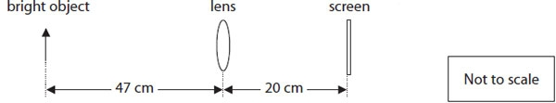
Calculate the focal length of the lens.
(3)

..............................................................................................................................................

Q2.
* Long sight and short sight are two defects of vision.
Explain how long sight and short sight are different from normal sight and how one of these defects can be corrected.
(6)
..............................................................................................................................................
..............................................................................................................................................
..............................................................................................................................................
..............................................................................................................................................
..............................................................................................................................................
..............................................................................................................................................
..............................................................................................................................................
..............................................................................................................................................
..............................................................................................................................................
..............................................................................................................................................
..............................................................................................................................................
..............................................................................................................................................

Q3.
(a) The diagram shows a human eye.
(i) Label part X.
(1)
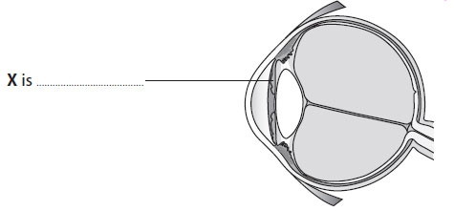
(ii) State the names of two parts of the eye that focus the light.
(2)
..............................................................................................................................................
..............................................................................................................................................
(b) A bright object is placed 47 cm away from a lens as shown in the diagram.
A real image of the bright object is seen on a screen which is 20 cm away from the lens as shown.
Calculate the focal length of the lens.
(3)

..............................................................................................................................................
*(c) Long sight and short sight are two defects of vision.
Explain how long sight and short sight are different from normal sight and how one of these defects can be corrected.
(6)
..............................................................................................................................................
..............................................................................................................................................
..............................................................................................................................................
..............................................................................................................................................
..............................................................................................................................................
..............................................................................................................................................
..............................................................................................................................................
..............................................................................................................................................
..............................................................................................................................................
..............................................................................................................................................
..............................................................................................................................................
..............................................................................................................................................
(Total for Question = 12 marks)

Q4.
* Medical physicists have developed endoscopes and many other devices to help doctors diagnose medical problems.
Compare the use of electromagnetic radiation in endoscopes and in one other diagnostic device.
(6)
..............................................................................................................................................
..............................................................................................................................................
..............................................................................................................................................
..............................................................................................................................................
..............................................................................................................................................
..............................................................................................................................................
..............................................................................................................................................
..............................................................................................................................................
..............................................................................................................................................
..............................................................................................................................................
..............................................................................................................................................
..............................................................................................................................................

Q5.
The graph shows how the intensity of ultrasound waves of different frequencies decreases as they penetrate soft tissue.
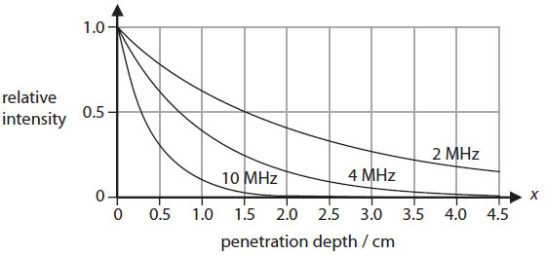
(i) Estimate how far a 2 MHz wave has penetrated into the soft tissue when its intensity is 25% of its original value.
(1)

..............................................................................................................................................
(ii) Explain which of these frequencies of ultrasound can be used to scan organs deep inside the body.
(2)
..............................................................................................................................................
..............................................................................................................................................
..............................................................................................................................................
..............................................................................................................................................

Q6.
The diagram shows light from a point source, S, spreading out as it gets further from S.
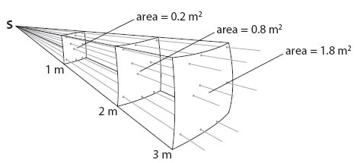
(a) The intensity of light passing through the surface which is 1 m from S is 2.5 W/m².
(i) Complete the sentence by putting a cross ( ) in the box next to your answer.
The intensity of light, in W/m², passing through the surface which is 2 m from S is
(1)
A 2.5 ÷ 2
B 2.5 ÷ 4
C 2.5 × 2
D 2.5 × 4
(ii) Calculate the power of the light passing through the surface which is 1m from S.
(2)

..............................................................................................................................................
(b) The graph shows how the intensity of ultrasound waves of different frequencies decreases as they penetrate soft tissue.
(i) Estimate how far a 2 MHz wave has penetrated into the soft tissue when its intensity is 25% of its original value.
(1)
..............................................................................................................................................

(ii) Explain which of these frequencies of ultrasound can be used to scan organs deep inside the body.
(2)
..............................................................................................................................................
..............................................................................................................................................
..............................................................................................................................................
..............................................................................................................................................
*(c) Medical physicists have developed endoscopes and many other devices to help doctors diagnose medical problems.
Compare the use of electromagnetic radiation in endoscopes and in one other diagnostic device.
(6)
..............................................................................................................................................
..............................................................................................................................................
..............................................................................................................................................
..............................................................................................................................................
..............................................................................................................................................
..............................................................................................................................................
..............................................................................................................................................
..............................................................................................................................................
..............................................................................................................................................
..............................................................................................................................................
..............................................................................................................................................
..............................................................................................................................................
(Total for Question = 12 marks)
Q7.
The diagram shows light from a point source, S, spreading out as it gets further from S.
The intensity of light passing through the surface which is 1 m from S is 2.5 W/m².
(i) Complete the sentence by putting a cross ( ) in the box next to your answer.
The intensity of light, in W/m², passing through the surface which is 2 m from S is
(1)
A 2.5 ÷ 2
B 2.5 ÷ 4
C 2.5 × 2
D 2.5 × 4
(ii) Calculate the power of the light passing through the surface which is 1m from S.
(2)

..............................................................................................................................................

Mark Scheme
Q1.
 | Answer | Acceptable answers | Mark
 | substitution (1) 1/f = 1/47 + 1/20 transposition or evaluation of 1/f (1) 0.071 evaluation of f (1) 14 (cm) | numbers that round down to 14 give full marks for the correct answer, no working | (3)

Q2.
 |  | Indicative Content | Mark
QWC | * | An explanation including some of the following points  • normal eye image forms on retina  • for all distances of objects  • short sight  • (clear) image of a distant object forms inside the eye / in front of retina  • corrected using diverging lens  • diverging the light / makes image distance longer  • long sight  • (clear) image of near object forms "beyond" the retina  • corrected using converging lens  • converging the light / makes image distance smallerOther methods of correction include  • contact lenses which change the curvature of the cornea  • laser correction changes curvature of cornea | (6)
Level | 0 | No rewardable content
1 | 1 - 2 | • a limited explanation of both long and short sight OR either long or short sight and how it is corrected eg long-sighted people cannot see near objects and this can be corrected by convex lenses  • the answer communicates ideas using simple language and uses limited scientific terminology  • spelling, punctuation and grammar are used with limited accuracy
2 | 3 - 4 | • a simple explanation of both long and short sight AND either how one is corrected or detail of image formation eg, longsighted people cannot see near objects but short sighted people cannot see distant objects because the image forms in front of retina.  • the answer communicates ideas showing some evidence of clarity and organisation and uses scientific terminology appropriately  • spelling, punctuation and grammar are used with some accuracy
3 | 5 - 6 | • a detailed explanation including both long and short sight AND how one is corrected AND detail of image formation eg long – eyeball too short so image of nearby object is beyond the retina, short-sighted people cannot see distant objects, which can be corrected by concave lenses  • the answer communicates ideas clearly and coherently uses a range of scientific terminology accurately  • spelling, punctuation and grammar are used with few errors

Q3.
 | Answer | Acceptable answers | Mark
(a)(i) | iris | allow any recognisable spelling | (1)
(a)(ii) | In either order  • cornea (1)  • lens (1) | aqueous humour vitreous humour  allow any recognisable spelling | (2)
(b) | substitution (1) 1/f = 1/47 + 1/20 transposition or evaluation of 1/f (1) 0.071 evaluation of f (1) 14 (cm) | numbers that round down to 14 give full marks for the correct answer, no working | (3)

 |  | Indicative Content | Mark
QWC | *(c) | An explanation including some of the following points  • normal eye image forms on retina  • for all distances of objects  • short sight  • (clear) image of a distant object forms inside the eye / in front of retina  • corrected using diverging lens  • diverging the light / makes image distance longer  • long sight  • (clear) image of near object forms "beyond" the retina  • corrected using converging lens  • converging the light / makes image distance smallerOther methods of correction include  • contact lenses which change the curvature of the cornea  • laser correction changes curvature of cornea | (6)
Level | 0 | No rewardable content
1 | 1 - 2 | • a limited explanation of both long and short sight OR either long or short sight and how it is corrected eg long-sighted people cannot see near objects and this can be corrected by convex lenses  • the answer communicates ideas using simple language and uses limited scientific terminology  • spelling, punctuation and grammar are used with limited accuracy
2 | 3 - 4 | • a simple explanation of both long and short sight AND either how one is corrected or detail of image formation eg, longsighted people cannot see near objects but short sighted people cannot see distant objects because the image forms in front of retina.  • the answer communicates ideas showing some evidence of clarity and organisation and uses scientific terminology appropriately  • spelling, punctuation and grammar are used with some accuracy
3 | 5 - 6 | • a detailed explanation including both long and short sight AND how one is corrected AND detail of image formation eg long – eyeball too short so image of nearby object is beyond the retina, short-sighted people cannot see distant objects, which can be corrected by concave lenses  • the answer communicates ideas clearly and coherently uses a range of scientific terminology accurately  • spelling, punctuation and grammar are used with few errors

Q4.
 |  | Indicative Content | Mark
QWC | * | A comparison of endoscopes with any one of the following devices: Diagnostic devices  • CAT scanners  • Fluoroscopes  • Thermal imagers / IR thermometers  • Pulse oximeters  • PET scanners  • X-ray machines  • Gamma camerasLink to electromagnetic radiation  • Endoscopes use TIR of light in optical fibres  • CAT scanners X- rays and computer to generate 3D images  • Fluoroscopes use X- rays and a video camera  • Thermal imagers use infrared emitted by a body  • IR / red LEDs used to measure oxygen levels  • PET scanners detect radiation emitted by electronpositron annihilation  • Gamma cameras detect gamma rays from radioactive sourcesOther factors for comparison  • Safety  • Ease of use  • Frequency / wave length  • Intensity  • Penetration  • Ionising / non-ionising | (6)
Level | 0 | No rewardable content
1 | 1 - 2 | • a limited comparison between an endoscope and one device e.g. endoscopes use light and CAT scanners detect broken bones  • the answer communicates ideas using simple language and uses limited scientific terminology  • spelling, punctuation and grammar are used with limited accuracy
2 | 3 - 4 | • a simple comparison between an endoscope and one device, linking them to the electromagnetic radiation used for both and a detail of use for one of them e.g. endoscopes use visible light to examine internal organs and CAT scans use X-rays  • the answer communicates ideas showing some evidence of clarity and organisation and uses scientific terminology appropriately  • spelling, punctuation and grammar are used with some accuracy
3 | 5 - 6 | • a detailed comparison between an endoscope and one device, linking them to the electromagnetic radiation used for both and a detail of use for both of them e.g. endoscopes use visible light which is passed down optical fibres by TIR to examine internal organs. Fluoroscopes use X-rays and a video camera to show positioning of stents in arteries.  • the answer communicates ideas clearly and coherently uses a range of scientific terminology accurately  • spelling, punctuation and grammar are used with few errors

Q5.
 | Answer | Acceptable answers | Mark
(i) | 3.0 +/- 0.5 (cm) |  | (1)
(ii) | an explanation linking  • 2 MHz (1)and any one from:  • has a higher intensity inside tissue (1)  • less energy absorbed (1)  • less attenuation (1)  • penetrates furthest /deepest (1) | this frequency alone RA  loses intensity more gradually highest penetration  accept "2MHz and 4MHz" with correct reason for 1 mark | (2)

Q6.
 | Answer | Acceptable answers | Mark
(a)(i) | B 2.5 ÷ 4 |  | (1)
(a)(ii) | either  P = 2.5 × 0.2  or  2.5 = P / 0.2 (1) 0.5 (W) (1) | give full marks for correct answer, no working | (2)
(b)(i) | 3.0 +/- 0.5 (cm) |  | (1)
(b)(ii) | an explanation linking  • 2 MHz (1)and any one from:  • has a higher intensity inside tissue (1)  • less energy absorbed (1)  • less attenuation (1)  • penetrates furthest /deepest (1) | this frequency alone RA  loses intensity more gradually highest penetration  accept "2MHz and 4MHz" with correct reason for 1 mark | (2)

 |  | Indicative Content | Mark
QWC | *(c) | A comparison of endoscopes with any one of the following devices: Diagnostic devices  • CAT scanners  • Fluoroscopes  • Thermal imagers / IR thermometers  • Pulse oximeters  • PET scanners  • X-ray machines  • Gamma camerasLink to electromagnetic radiation  • Endoscopes use TIR of light in optical fibres  • CAT scanners X- rays and computer to generate 3D images  • Fluoroscopes use X- rays and a video camera  • Thermal imagers use infrared emitted by a body  • IR / red LEDs used to measure oxygen levels  • PET scanners detect radiation emitted by electronpositron annihilation  • Gamma cameras detect gamma rays from radioactive sourcesOther factors for comparison  • Safety  • Ease of use  • Frequency / wave length  • Intensity  • Penetration  • Ionising / non-ionising | (6)
Level | 0 | No rewardable content
1 | 1 - 2 | • a limited comparison between an endoscope and one device e.g. endoscopes use light and CAT scanners detect broken bones  • the answer communicates ideas using simple language and uses limited scientific terminology  • spelling, punctuation and grammar are used with limited accuracy
2 | 3 - 4 | • a simple comparison between an endoscope and one device, linking them to the electromagnetic radiation used for both and a detail of use for one of them e.g. endoscopes use visible light to examine internal organs and CAT scans use X-rays  • the answer communicates ideas showing some evidence of clarity and organisation and uses scientific terminology appropriately  • spelling, punctuation and grammar are used with some accuracy
3 | 5 - 6 | • a detailed comparison between an endoscope and one device, linking them to the electromagnetic radiation used for both and a detail of use for both of them e.g. endoscopes use visible light which is passed down optical fibres by TIR to examine internal organs. Fluoroscopes use X-rays and a video camera to show positioning of stents in arteries.  • the answer communicates ideas clearly and coherently uses a range of scientific terminology accurately  • spelling, punctuation and grammar are used with few errors

Q7.
 | Answer | Acceptable answers | Mark
(i) | B 2.5 ÷ 4 |  | (1)
(ii) | either  P = 2.5 × 0.2  or  2.5 = P / 0.2 (1) 0.5 (W) (1) | give full marks for correct answer, no working | (2)

Examiner's Report
Q1.
It was good to see that well over half the candidates were able to score some marks in using the lens equation, with many of them scoring all 3. It was disappointing to see that some candidates did not even score the 1 mark available for substituting the values for the object and image distances into the equation.
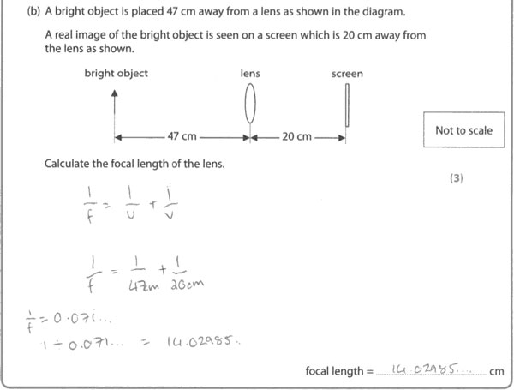
Results Plus: Examiner Comments
All the steps are set out clearly here, making the work easy to follow and reducing the chances of making a mistake.

Results Plus: Examiner Tip
There are too many figures quoted in the answer here. It is good to remember that the number of significant figures in the answer should be the same as in the question.

Q2.
This was a straightforward question in which candidates' understanding of some defects of vision and their correction was tested. The best responses were well structured, logical explanations involving the causes and effects, and a correction for one of them. Responses which were not presented in a structured way often became confused or even contradictory.
There were a lot of excellent responses to this question.
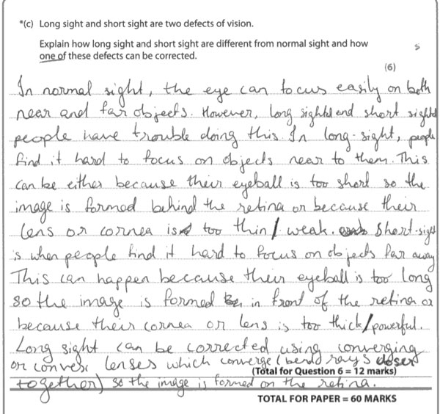
Results Plus: Examiner Comments
This discusses what each defect is with optical detail and how long sight is corrected.

Q3.
(a)(i)
It was pleasing to see that the vast majority of candidates were able to correctly label the iris on a diagram of the human eye.
(a)(ii)
Most candidates were able to name two parts of the eye involved in focussing with only a very few being unable to score at least one of the marks.
(b)
It was good to see that well over half the candidates were able to score some marks in using the lens equation, with many of them scoring all 3. It was disappointing to see that some candidates did not even score the 1 mark available for substituting the values for the object and image distances into the equation.
Results Plus: Examiner Comments
All the steps are set out clearly here, making the work easy to follow and reducing the chances of making a mistake.

Results Plus: Examiner Tip
There are too many figures quoted in the answer here. It is good to remember that the number of significant figures in the answer should be the same as in the question.

(c)
This was a straightforward question in which candidates' understanding of some defects of vision and their correction was tested. The best responses were well structured, logical explanations involving the causes and effects, and a correction for one of them. Responses which were not presented in a structured way often became confused or even contradictory.
There were a lot of excellent responses to this question.
Results Plus: Examiner Comments
This discusses what each defect is with optical detail and how long sight is corrected.

Q4.
A comparison was required here between the uses of electromagnetic radiation in two different diagnostic devices. One of these, an endoscope, was given but there was a free choice for the second. The best responses identified the second device and both radiations involved and went into some detail about the use of each device. Responses which involved radiation other than electromagnetic failed to score.
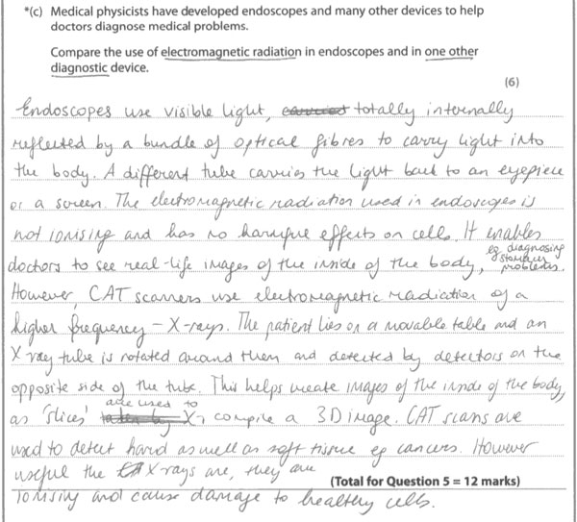
Results Plus: Examiner Comments
The candidate has identified visible light as the radiation used in endoscopes and as X-Rays in CAT scanners. There is then some good detail about the use and risks in each case.

Results Plus: Examiner Tip
It is good practice to do as this candidate did and underline the key words before answering the question. It would have been better in this case if the word 'compare' had also been underlined as this is the command word of the question.

Q5.
(i)
This required candidates to estimate a value on the y-axis from a family of curves. Most were able to do this successfully.
(ii)
Candidates had to explain their choice of frequency of ultrasound for scanning organs deep inside the body.
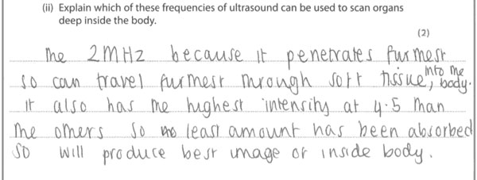
Results Plus: Examiner Comments
This is a good explanation which does more than just repeat the question.

Q6.
(a)(ii)
This involved analysing and using some quite complex data about the inverse square law and rearranging an equation. The most common error was to use the wrong value for the area.
(b)(i)
This required candidates to estimate a value on the y-axis from a family of curves. Most were able to do this successfully.
(b)(ii)
Candidates had to explain their choice of frequency of ultrasound for scanning organs deep inside the body.
Results Plus: Examiner Comments
This is a good explanation which does more than just repeat the question.

(c)
A comparison was required here between the uses of electromagnetic radiation in two different diagnostic devices. One of these, an endoscope, was given but there was a free choice for the second. The best responses identified the second device and both radiations involved and went into some detail about the use of each device. Responses which involved radiation other than electromagnetic failed to score.
Results Plus: Examiner Comments
The candidate has identified visible light as the radiation used in endoscopes and as X-Rays in CAT scanners. There is then some good detail about the use and risks in each case.

Results Plus: Examiner Tip
It is good practice to do as this candidate did and underline the key words before answering the question. It would have been better in this case if the word 'compare' had also been underlined as this is the command word of the question.

Q7.
(ii)
This involved analysing and using some quite complex data about the inverse square law and rearranging an equation. The most common error was to use the wrong value for the area.

